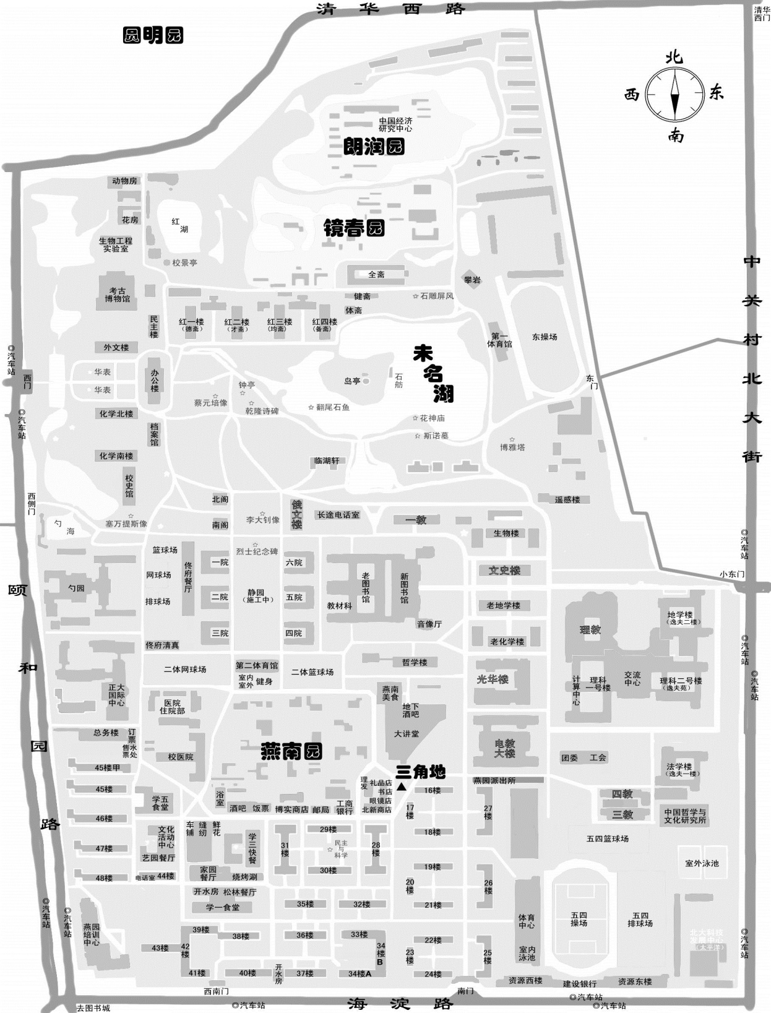
W
E
农
园
食
堂
⑥
⑤
④
③
②
①
B
S
N
C
A
A: 酒店：北京锡华宾馆 Hotel：Xihua Hotel, Beijing
B: 暑期学校教室：北京大学第三教学楼 Classroom of the summer school: Room 107, Classroom Building 3
C: 会议地点：中关新园1号楼 Conference venue: Building 1, Zhongguanyuan Global Village

- 肯德基餐厅 KFC
- 北京大学西南门 Southwest Gate of Peking University
- 农园餐厅 Nongyuan Dinning Hall
- 五四操场 Wusi Stadium
- 理科二号楼 Science Building 2
- 北京大学东南门 Southeast Gate of Peking University

